Chapter 5, Solution 74.

Let v₁ = output of the first op amp
v₂ = input of the second op amp.

The two sub-circuits are inverting amplifiers

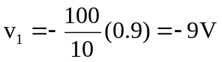
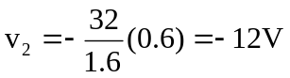
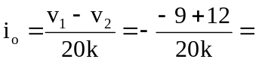 150 μA.

